**Identification of Iraqi Wild Mushrooms**

Author Name¹*, Co-author Name²

¹ *Affiliation 1*  
² *Affiliation 2*

*Corresponding author: email@example.com

DOI: https://doi.org/xxxxxxxxxxx

**Abstract**

This is a concise summary of the research, covering objectives, methods, key findings, and conclusions in 200–300 words. This is a concise summary of the research, covering objectives, methods, key findings, and conclusions in 200–300 words. This is a concise summary of the research, covering objectives, methods, key findings, and conclusions in 200–300 words. This is a concise summary of the research, covering objectives, methods, key findings, and conclusions in 200–300 words.

**Keywords**: Mycology; Truffle; Desert fungi; Biodiversity; Cultivation.

**1. Introduction**

This is a concise summary of the research, covering objectives, methods, key findings, and conclusions in 200–300 words (Karim et al. 2021). This is a concise summary of the research, covering objectives, methods, key findings, and conclusions in 200–300 words. This is a concise summary of the research, covering objectives, methods, key findings, and conclusions in 200–300 words. Ali (2007) is a concise summary of the research, covering objectives, methods, key findings, and conclusions in 200–300 words (Karim & Ali, 2021).

**2. Materials and Methods**

**3. Results and Discussion**

**4. Conclusion**

**Funding**

This research received no external funding.

**Acknowledgements (Optional)**

**Conflicts of Interest**

The authors declare no conflict of interest

**References**

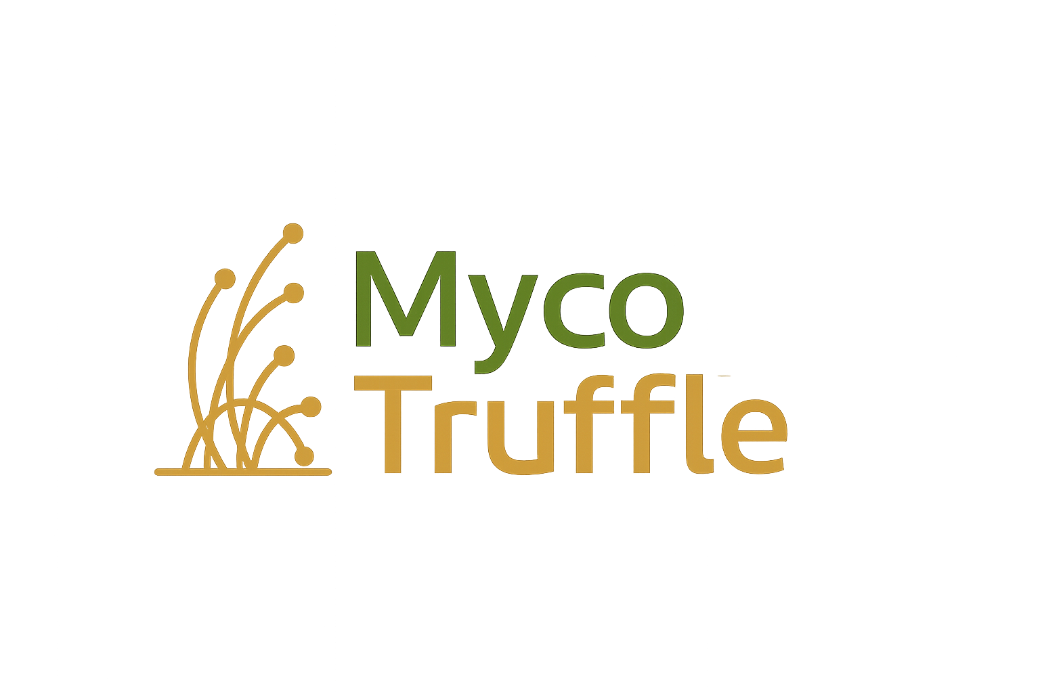  
  
**Figure 1**. Sample image of a wild mushroom species

**Table 1**. Sample image of a wild mushroom species

|  |  |  |
| --- | --- | --- |
| **Species** | **Habitat** | **Observation Date** |
| Agaricus sp. | Forest edge | March 2025 |
|  |  |  |
|  |  |  |

**How to cite this article:**

Author Last Name, Initials. (Year). Identification of Iraqi wild mushrooms. MycoTruffle – Journal of Mycology and Truffles, Volume(Issue), pages. https://doi.org/xxxxx

**Examples of References: APA System**

- One author: Smith, J. (2023). Mycology studies in desert regions. Mycology Journal, 12(2), 100–110.

- Two authors: Ali, M., & Hussein, R. (2022). Truffle biodiversity in Iraq. *Iraqi J. Biol. Sci.*, 15(1), 50–60.

- More than three authors: Karim, A., Yasin, L., Mahmoud, R., & Omar, N. (2021). Desert fungi classification. *Journal of Fungal Research*, 5(3), 200–210.

- Article with DOI: Taylor, P. (2020). Soil-fungi interactions. *Journal of Mycology*, 10(1), 1–9. https://doi.org/10.1016/j.myco.2020.01.005

- Conference paper: Abbas, T. (2019). Mycorrhizal networks in arid zones. In Proc. 10th Int. Conf. Mycology (pp. 100–105). Baghdad, Iraq.

- Book: Johnson, L. (2018). Fungal Biology (2nd ed.). pp.544. Academic Press.

- Book chapter: Rahman, S. (2021). Truffle cultivation techniques. In A. Brown (Ed.), Advances in Mycology (pp. 120–145). Springer.

- Website: World Mycology Database. (2023). Retrieved from https://www.worldmycology.org